**Y6 Teams - How to solve problems we’ve come across**

I will add to this as we sort problems out, so these will not be in any paticular order. However, hopefully, they will help!

**Working on a document in Teams**

When you click onto the assignment, look for the ‘My work’ section towards the bottom of the page

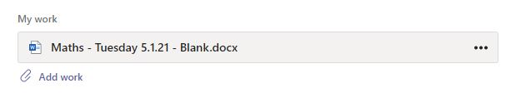

If you click on the three dots to the right, you get the following options:

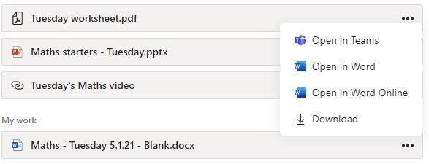

If you choose ‘Open in Teams’, the document will open within Teams and you can work on it there. Please make sure once you have clicked ‘Close’, you then submit your work.

If you open it in Word or download it, the following pieces of advice may be helpful.

**How do I find a document I have downloaded?**

If you have downloaded a document instead of working on screen, you need to go to the Downloads section on your device. If it’s a laptop or a PC, you need to click on the yellow folder along the bottom of your screen:



then look in the ‘Downloads’ folder:

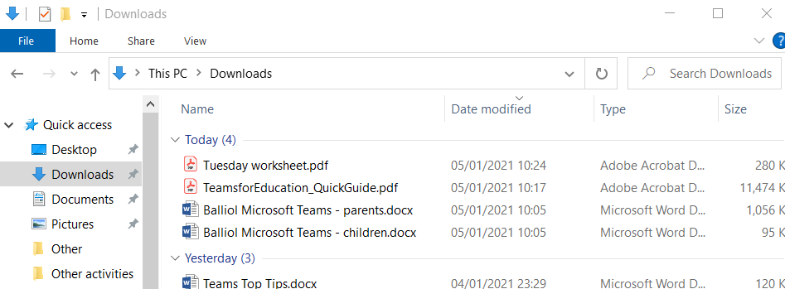

**How do I upload work that I have made myself, or taken a picture of?**

THIS IS REALLY IMPORTANT! Please upload your work like this, otherwise, we may not see it and we won’t be able to give you feedback.

To do this, you need to have saved your document or picture onto the device that you are using Teams on.

When you click into the assignment, look for the ‘My work’ section. You will see a paper clip with ‘Add work’ next to it.



When you click on ‘Add work’, this will come up:

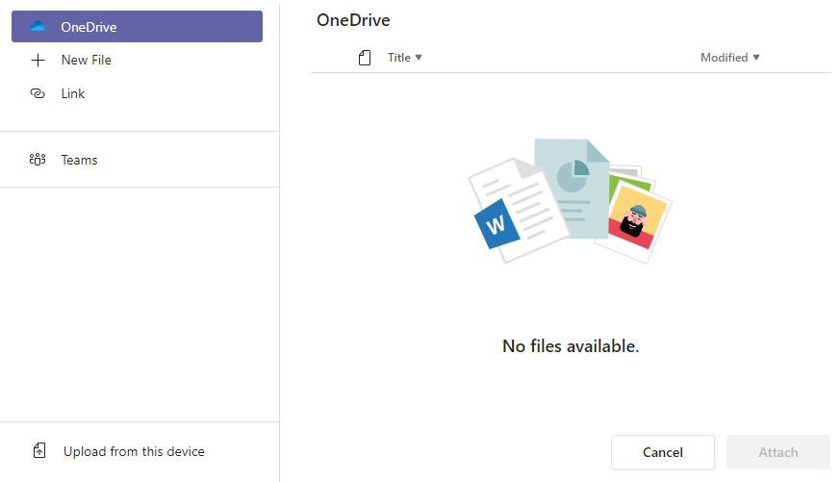

Click on ‘Upload from this device’, then a window will come up to help you find what you want to upload:

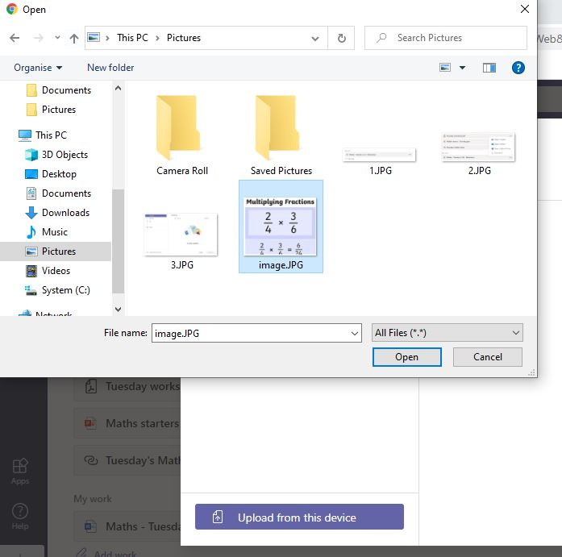

Once you have selected the thing you want to upload and clicked ‘Open’, you will see this:

Click ‘Done.’

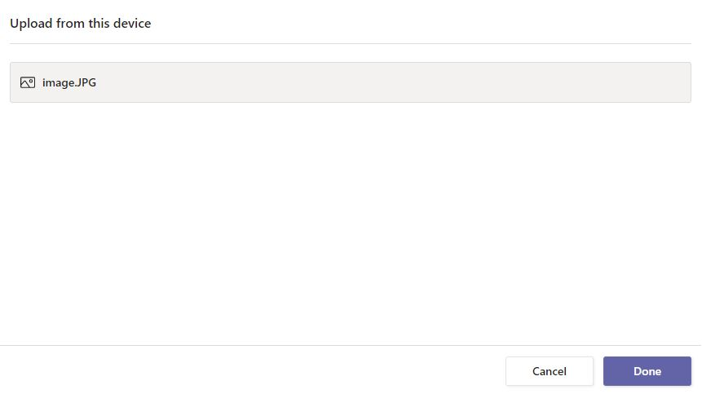

Your work will then appear in the assignment

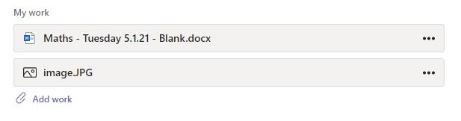

To make sure you hand your work in, go back to the top of the page and click:



We will now be able to look at your work and give you feedback.

If you are unable to do this, please EMAIL us your work. Please DO NOT put photos of it in the chat as we will not be able to give you feedback.